Exercises

1) We want to give Batman a sidekick—namely, Robin. How or what would you add to the KG fragment to express this additional information.

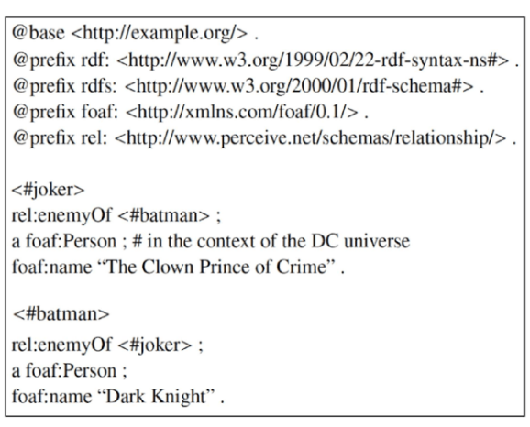

Solution:

<#batman>

rel:enemyOf <#joker> ;

rel:sidekick <#robin> ;

a foaf:Person ;

foaf:name "Dark Knight".

<#robin>

...

2) The FOAF vocabulary can be accessed at the link that is provided in the prefix. Go to the link and study some of the classes and properties listed in FOAF Core. Can you use FOAF to add a single statement to the Turtle fragment that expresses the information that the Joker is 32 years old?

Solution:

@prefix rel: <http://www.perceive.net/schemas/relationship#> .

@prefix rdf: <http://www.w3.org/1999/02/22-rdf-syntax-ns#> .

@prefix rdfs: <http://www.w3.org/2000/01/rdf-schema#> .

@prefix foaf: <http://xmlns.com/foaf/0.1/> .

@prefix xsd: <http://www.w3.org/2001/XMLSchema#> .

<#joker>

rel:enemyOf <#batman> ;

a foaf:Person ;

foaf:name "The Crown Prince of Crime";

foaf:age "32"^^xsd:string.

3) Write out the entire portion of the fragment from <#batman> downward in N-triples.

Solution:

<http://example.org#batman><http://www.perceive.net/schemas/relationship#enemyOf> <http://example.org#joker> .

<http://example.org#batman> <http://www.w3.org/1999/02/22-rdf-syntax-ns#type> <http://xmlns.com/foaf/0.1/Person> .

<http://example.org#batman> <http://xmlns.com/foaf/0.1/name> "Dark Knight" .

4) Let us try to compare the reduction in complexity that can be incurred by using Turtle instead of N-triples. Suppose we measure complexity in terms of both the number of terms as well as statements, for example, the fragment that you rewrote above in N-triples has four statements in Turtle, and seven terms (the single subject <#batman>, three predicates, and three objects, one of which is a literal). Suppose that you were told that your KG had only URIs and no literals. Furthermore, your KG has 1,000,000 nodes, each of which has four predicates (you may assume that these are all unique) linking it to four other nodes on average. You may also assume that everything has a single common prefix, so Turtle only involves a single additional statement declaring the prefix. Ignoring this prefix statement, how many statements and terms would be in your KG representation if expressed in Turtle? How about N-triples? What are the percentage reductions in statements and terms if Turtle is used over N-triples?

Solution:

In N-triples,

1M nodes - 4 predicates each

4M nodes in subject ; 4M nodes in predicates ; 4M nodes in objects

All the nodes in N-triples are URI's

In Turtle,

1M nodes – 4 predicates each

1M nodes in subject ; 4M nodes in predicates ; 4M nodes in objects

All the nodes in turtle are terms.

% of reduction = (12 – 9) / 12 = 25%

5) You are told that “John Green, Michael Brown, and Jerry Red are members of the Mensa organization,” and that “Michael Brown is additionally a member of IEEE. Michael and John are friends, while Jerry’s current project involves using AI for social good.” Using FOAF and/or some of the vocabularies covered in the “Software and Resources” section, could you write out the “knowledge” expressed in that sentence in the Turtle format? For this question, you should not be using made up terms (i.e. any terms that you use must be defined already in an established vocabulary). Values such as names and literals can be mnemonically proposed if necessary.

Solution:

@prefix rel: <http://www.perceive.net/schemas/relationship#> .

@prefix rdf: <http://www.w3.org/1999/02/22-rdf-syntax-ns#> .

@prefix rdfs: <http://www.w3.org/2000/01/rdf-schema#> .

@prefix foaf: <http://xmlns.com/foaf/0.1/> .

<#johnGreen>

rel:friendOf <#michaelBrown> ;

a foaf:Person ;

foaf:name "John Green";

foaf:Organization "Mensa organization".

<#michaelBrown>

rel:friendOf <#johnGreen> ;

a foaf:Person ;

foaf:name "Michael Brown";

foaf:Organization "Mensa organization"

foaf:member "IEEE".

<#jerryRed>

a foaf:Person ;

foaf:name "Jerry Red";

foaf:Organization "Mensa organization";

foaf:currentProject "AI for social good".

6) Returning to the motivation proposed behind the Wikidata data model, can you list properties of countries that must be recorded as n-ary (n > 2) relations?

Solution:

7) State whether the statements below are True or False. If false, state the reason (simply) and correct the statement by adding, removing, or modifying elements.

(a) RDF extends the linking structure of the web to use URIs to name the relationship between things and the two ends of the link (Subject and Object). - True

(b) In Turtle (textual syntax for RDF) it is not allowed to use untyped (plain) literals. - False

(c) RDF can be used to represent information only about things that can be directly retrieved on the web. -

(d) A resource can be represented by a blank node. - True

(e) Copyright or licensing information of some resource cannot be represented with RDF. - False

(f) The XML RDF syntax can describe some resources that cannot be described using the Turtle RDF syntax. - False

8) A friend remarks to you, “RDFS is a language intended to represent the structure of RDF resources.” What does the word “structure” mean in this context?

Solution:

RDF in general is a method of conceptual data modeling. RDFS provides a mechanism for describing groups of related resources (RDF), and the relation between them.

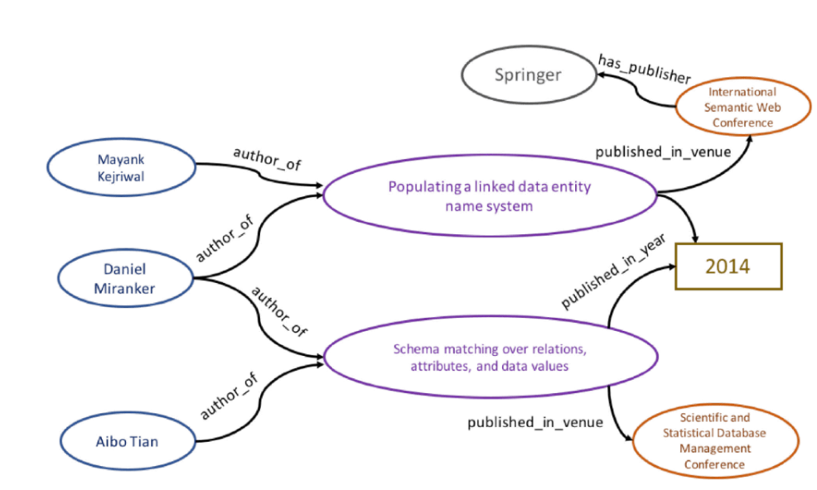9) Consider the academic KG example in chapter 1 (figure 1.5) and show what its representation would look like as (a) a property graph, and as (b) a property table. Make assumptions as appropriate. What is one good example of a multivalued property in figure 1.5, of which object values should belong in a separate table?

Solution:

{

‘name’:’Mayank Kejriwal’

}

{ ‘title’ : ‘Populating a linked

...’

‘published in venue:’ISWC’

‘hasPublisher’:’Springer’

‘year’:2014 }

{ ‘

title’ : ‘Schema complete’

‘published in venue:’SSDB’

‘year’:2014

}

Property Graph

{

‘name’:’Daniel Miranker’

}

{

‘name’:’Albo Tianl’

}

Property Table: Publication

|  |  |  |  |  |
| --- | --- | --- | --- | --- |
| Name | author_of | publishedin_venue | has_publisher | p_year |
| Mayank Kejriwal | Populating linked data | ISWC | Springer | 2014 |
| Danieal Miranker | Populating linked data | ISWC | Springer | 2014 |
| Albo Tiani | Populating linked data | ISWC | Springer | 2014 |
| Danieal Miranker | Schema complete | SSDB | Null | 2014 |
| Albo Tiani | Schema complete | SSDB | Null | 2014 |

10) What is an example of a Wikidata entity that is an instance of Item and is linked to an instance of Geographic Shape? What property links the item to the geographic shape?

Note: You may have to look around on Wikidata to find such an entity

Solution:

11) Look up the entry for COVID-19 on Wikidata and answer the following questions:

(a) What is COVID-19 an instance of?

(b) What is the type of resource that COVID-19 is linked to via the property number of deaths?

(c) What is the type of the resource linked via the property significant event (if there is more than one, pick the first one)? What is the Wikidata ID of this resource? Name the property that links this resource back to the COVID-19 resource you started from.

https://www.wikidata.org/wiki/Q84263196

Solution:

(a) emerging communicable disease, atypical pneumonia

(b) point in time (P585)

(c) COVID-19 pandemic (Q81068910)